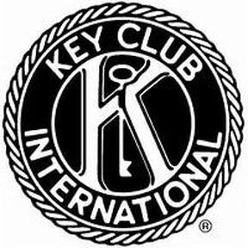
Texas-Oklahoma District
R.L. Paschal Key Club

Agenda: 8/22/18

Pledge: I pledge on my honor to uphold the objects of Key Club International; to build my home, school, and community; to serve my nation and God and to combat all forces which tend to undermine these institutions.
Contact me via 817-709-8293 or paschalkeyclubpresident@gmail.com if you have any questions or want to RSVP for a service project!

Announcements:
- If you have any questions or concerns, contact me or any other board member!
- You can receive Key Club Remind101 notifications by texting @paschalk to: 81010
- Join our Facebook page at R.L. Paschal Key Club and follow our Instagram @paschalkeyclub . Add us on snapchat: paschalkeyclub
- FIRST MEETING: September 11, Room 153, 8:00 AM SHARP

Events Coming Up:

- Braille Bibles
  - 4:00-5:00 P.M. Wednesday, August 23, 2018
  - Help make Braille Bibles at St. Paul Lutheran Church (1800 W Fwy)
- Agape- Feeding the Homeless
  - 5:30-7:30 P.M. Thursday, August 24, 2018
  - Volunteers needed to serve food to the homeless
  - Broadway Baptist Church (305 W. Broadway Ave.)
- Panera Fundraiser
  - August 23, 4-8 PM
  - Panera on 1700 S University Dr
  - We receive 20% of the proceeds, but you need to show the flyer for us to get the money!
  - We use this money to help pay for DCON and service projects.
- Trinity Trash Bash
  - September 15, 8:30-11:00 AM
  - 3200 Riverfront Dr (near Woodshed smokehouse)
  - Help clean up trash along the Trinity River
  - Next 6 people to sign up get a free T-shirt!
  - Free after party at Panther Island Pavilion

